NAME: K. SARANYA
ROLL NO: A24126552090
BRANCH: CSM
SECTION: B
COURSE NAME: FULL STACK WEB DEVELOPMENT
CODE: 23CM4121
TITLE OF THE EXPERIMENT:
To understand how CSS3 enhances the appearance of web pages and explore HTML5 graphics using the Canvas element.
DESCRIPTION:-
This experiment demonstrates the use of CSS3 features to enhance the appearance and layout of web pages. It uses gradients, text shadows, rounded corners, box shadows, hover effects, flexible card layouts, navigation styling, buttons, and a styled footer. It also explores the HTML5 Canvas element with JavaScript to draw a rectangle, circle, line, and the student's name. These features are combined to create a simple and attractive styled webpage.
PROGRAM:-
<style>
.site-header {
background: linear-gradient(to right, #4facfe, #00f2fe);
color: white;
font-family: 'Segoe UI', sans-serif;
font-size: 30px;
text-align: center;
padding: 30px;
text-shadow: 2px 2px 5px rgba(0, 0, 0, 0.4);
}
.site-header p {
font-size: 16px;
font-weight: normal;
margin-top: 8px;
}
.navbar {
background-color: #222;
text-align: center;
padding: 14px;
}
.navbar a {
color: #f4f4f4;
margin: 0 18px;
text-decoration: none;
font-family: Arial, sans-serif;
font-size: 16px;
}
.navbar a:hover {
color: #ff6600;
}
.section-title {
text-align: center;
font-family: 'Segoe UI', sans-serif;
margin-top: 30px;
color: #333;
}
.cards {
display: flex;
justify-content: center;
gap: 25px;
margin: 25px;
flex-wrap: wrap;
}
.card {
background-color: #ffffff;
border: 2px solid #e0e0e0;
border-radius: 14px;
padding: 22px;
width: 200px;
box-shadow: 4px 4px 12px rgba(0, 0, 0, 0.15);
text-align: center;
font-family: Georgia, serif;
}
.card:hover {
transform: translateY(-5px);
}
.card h3 {
font-size: 19px;
color: #4facfe;
}
.card p {
font-size: 14px;
color: #555;
}
.card button {
padding: 8px 18px;
border: none;
border-radius: 6px;
background-color: #4facfe;
color: white;
cursor: pointer;
margin-top: 12px;
font-size: 14px;
}
.card button:hover {
background-color: #0077cc;
}
.site-footer {
background-color: #222;
color: #ccc;
text-align: center;
padding: 18px;
margin-top: 30px;
font-family: Arial, sans-serif;
font-size: 14px;
}
.canvas-section {
text-align: center;
margin: 25px 0;
}
canvas {
border: 1px solid #000;
display: block;
margin: 15px auto;
}
</style>

<!-- ===== Part A: HTML5 Canvas ===== -->
<div class="canvas-section">
<h2 class="section-title">Canvas Graphics</h2>
<p style="font-family: Arial, sans-serif; color:#666;">
A simple rectangle, circle, line, and my name drawn using JavaScript on the HTML5 canvas.
</p>
<canvas id="myCanvas" width="400" height="250"></canvas>
</div>

<script>
const canvas = document.getElementById("myCanvas");
const ctx = canvas.getContext("2d");

ctx.fillStyle = "skyblue";
ctx.fillRect(20, 20, 100, 60);

ctx.beginPath();
ctx.arc(220, 60, 40, 0, Math.PI * 2);
ctx.fillStyle = "orange";
ctx.fill();

ctx.beginPath();
ctx.moveTo(20, 150);
ctx.lineTo(300, 150);
ctx.stroke();

ctx.font = "20px Arial";
ctx.fillStyle = "black";
ctx.fillText("Saranya", 20, 200);
</script>

<!-- ===== Part B: CSS3 Styled Webpage Layout ===== -->
<header class="site-header">
<h1>My Styled Webpage</h1>
<p>Showcasing CSS3 styling with gradients, shadows, and hover effects</p>
</header>

<nav class="navbar">
<a href="#">Home</a>
<a href="#">About</a>
<a href="#">Contact</a>
</nav>

<h2 class="section-title">What I Bring</h2>
<div class="cards">
<div class="card">
<h3>About Me</h3>
<p>A student learning web design, currently exploring HTML5, CSS3, and JavaScript basics.</p>
<button>Read More</button>
</div>
<div class="card">
<h3>My Skills</h3>
<p>Building structured layouts, styling with CSS3, and adding simple canvas graphics.</p>
<button>View Skills</button>
</div>
<div class="card">
<h3>Get in Touch</h3>
<p>Open to feedback and collaboration on small web development projects.</p>
<button>Contact Me</button>
</div>
</div>

<footer class="site-footer">
<p>&copy; 2026 My Styled Webpage | Designed and Coded by Saranya</p>
</footer>

OUTPUT:-
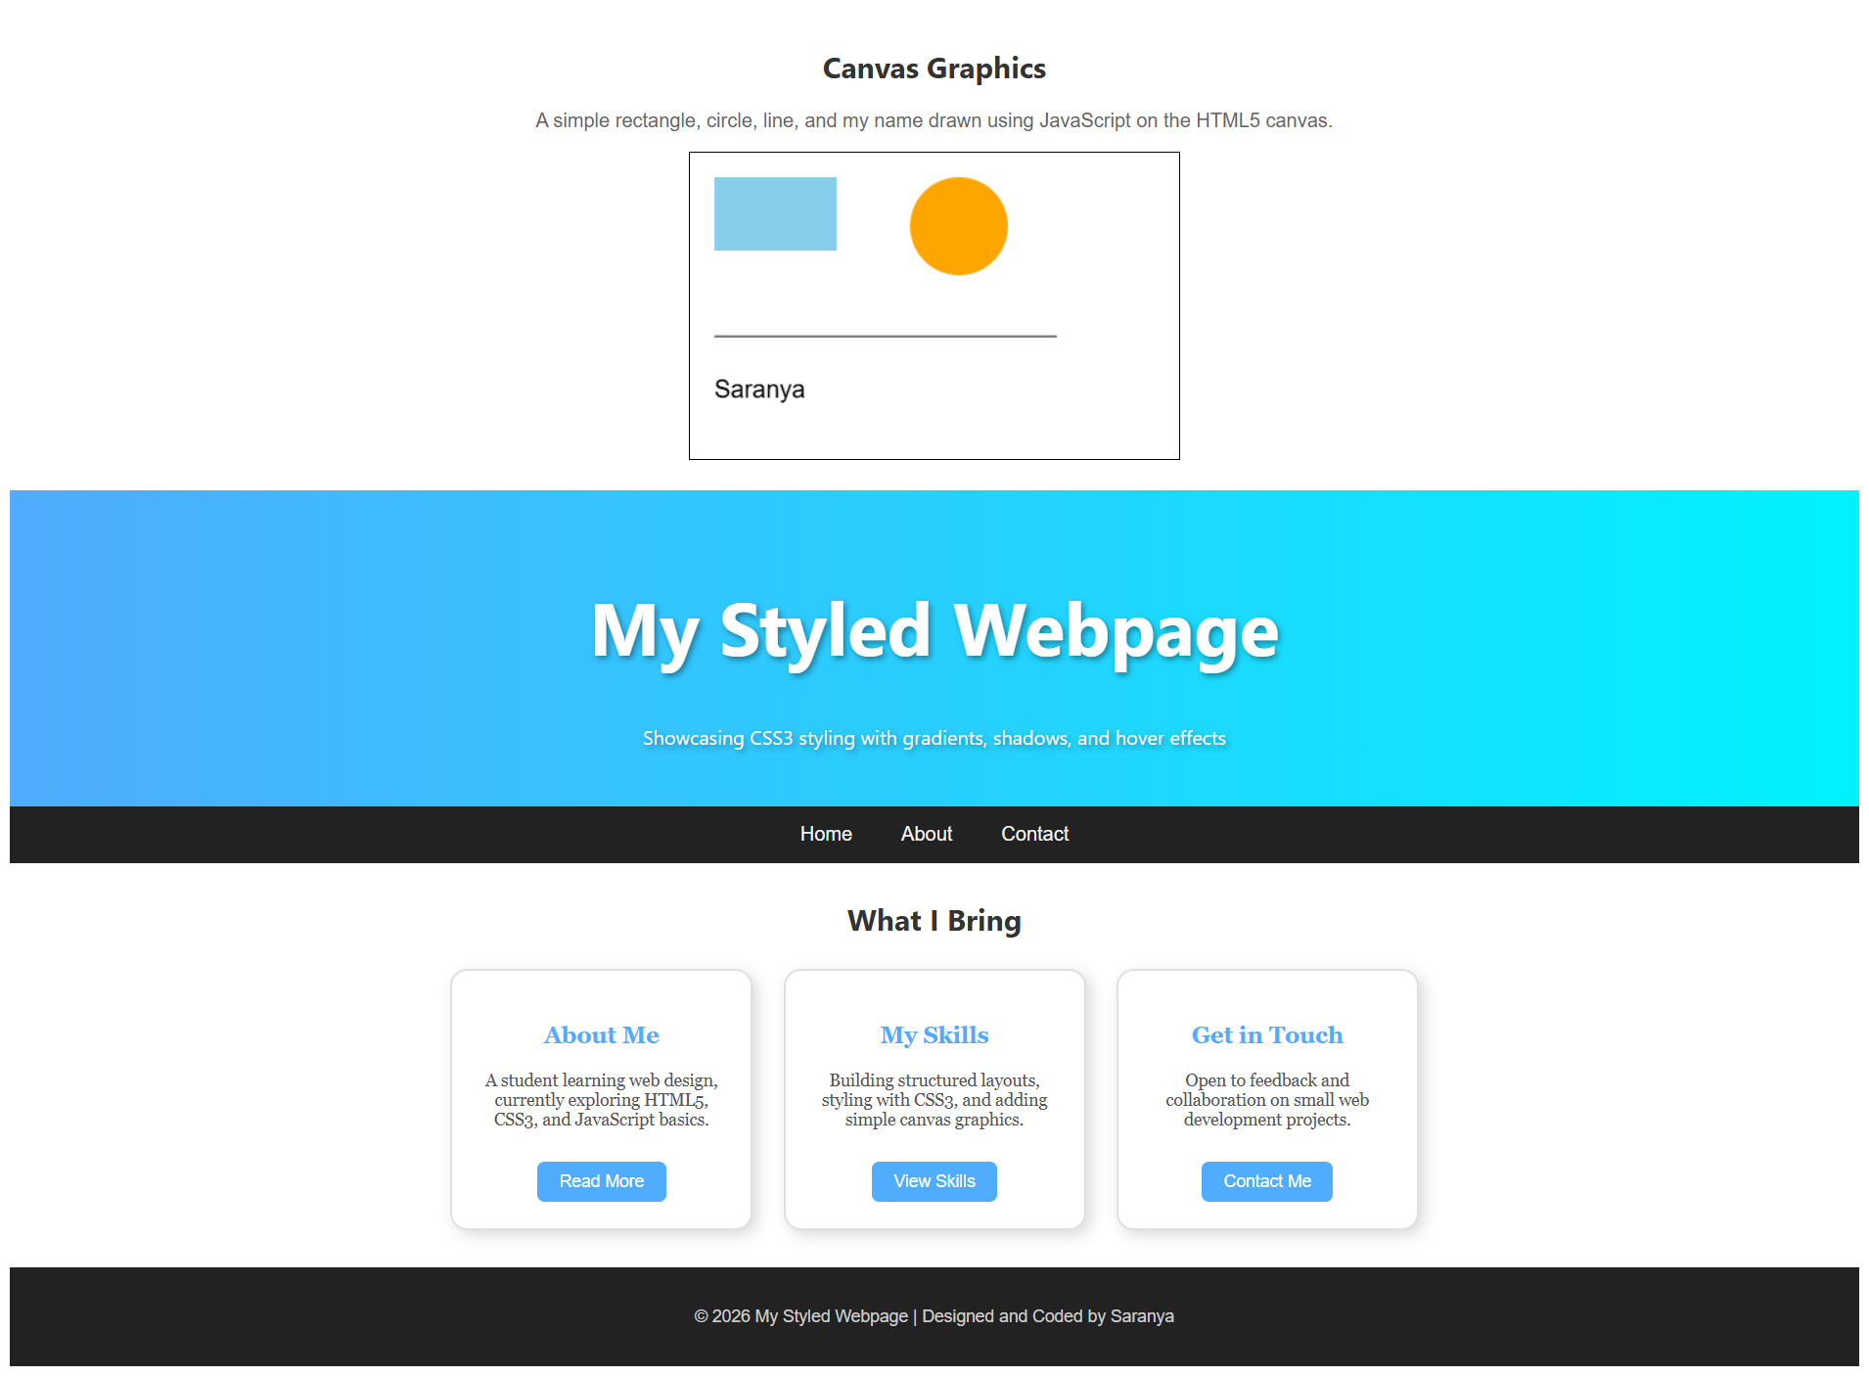
THANK YOU

